**ShopSmart** - *Get the best deals near you.*

**Members**

Morgan Harrison, Dominic Tekanene, Tyler Winmill, Oscar McDougall

**Datasets**

**Fuel Mileage by Vehicle** – <https://fueleconomy.gov/feg/ws/>

**Distance Matrix** – <https://developers.google.com/maps>

**Groceries and Prices** – *Countdown / New World / PAKn’SAVE Online Shopping Web Endpoints*

**What Are You Going to Build?**

**ShopSmart** - Get the best deals near you.

Pretty much all major supermarket chains now have an online shopping option, which lets you see the price of groceries at any given location, including current specials and membership deals.

This application would allow users to select supermarkets around their physical location (PAK’NSAVE, Countdown, New World), then search all those stores at once and build a shopping list of groceries they need. The application would take the associated ID’s of the locations, search their online shopping databases to grab the respective prices at each location for each item on their list, generating a total for each location.

Users can then enter their car model and make, which will use publicly available mileage data and maps data to estimate the total cost to travel to and from each location, and add that to the total price summary, letting them see which location is going to be most cost effective overall in terms of grocery prices and cost of transport.

**Why Do They Work Together?**

These datasets work together perfectly because most people tend to use their cars to go grocery shopping.

By estimating these additional costs for each location, our application can give people the absolute best value for their money when it comes to grocery shopping in their local area.

**How Are You Going to Build It?**

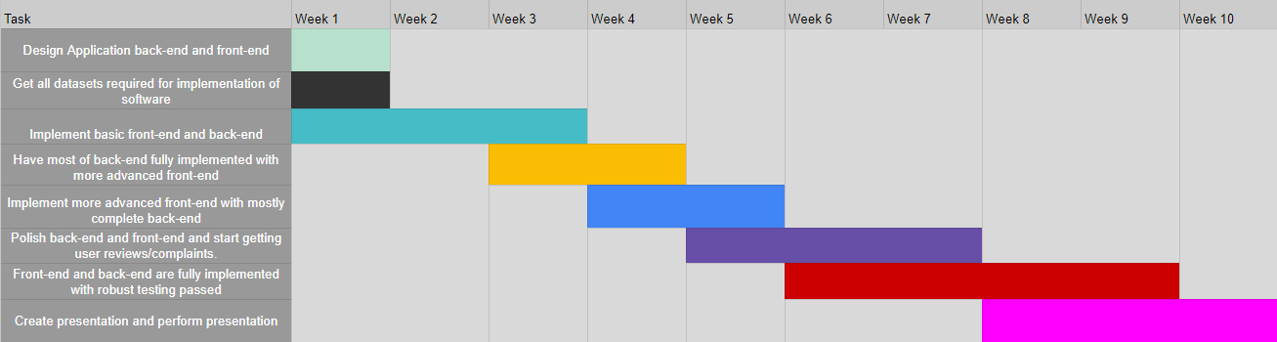

There will be 2 main parts to our application, the back-end and front-end.

For the back-end we’ll need to build a robust system for interfacing with all the different online shopping providers, after some preliminary research we’ve found that both New World and PAK’nSAVE use the same system for their online shopping, while Countdown uses its own independent system.

We’ll have to create a system that allows the software to grab the associated ID’s of stores surrounding the users geolocation in an adjustable radius, then using that ID query the individual store with the users inputted search query, returning the currently available products and their prices.

The front-end will take the information sourced from the back-end and display it in an easy to understand, user friendly way. Users will be able to search for shopping locations around them, pick their desired locations and search these locations for products to build their shopping list, additionally they’ll have the option to enter their current location, vehicle model and make and estimate the fuel expenses for traveling to and from each location, which will be seamlessly added to the total for each store.

The workload will be effectively distributed between each team member according to their particular strengths.

**Morgan & Oscar** – Will work on the back-end of the project, handling the bulk of data storage and retrieval.

**Tyler** – Will work on a mix of back-end and front-end, primarily handling data input for the front-end.

**Oscar** – Will additionally work on front-end design, ensuring the UI is user friendly and beautifully designed.

**Dominic** – Will work on a mixture of both front and back-end, focusing as well on ensuring effective and optimal data storage and retrieval.

Our application will be built in either C or C++ and will utilize local caching for redundancy.

**What already exists that is similar to your app?**

There are apps that have only partial capabilities as to what we are trying to overall accomplish:

**Groceries** – Countdown/New World/PAK’nSAVE Grocery Api

**Distance Matrix** – Google Maps

**Evidence That There is Customer Interest in Your App:**

With gas prices reaching their all time highs in the year of 2023, and with a 7.2% increase in the cost of living, a large portion of that contributed by a 12.7% increase in average household grocery prices, Kiwi’s now more than ever are looking for the best deals when it comes to buying their essentials.

Our application aims to tackle in some part the pain Kiwi’s are feeling on their pockets by allowing consumers to make the most informed decisions when it comes to buying their groceries.

We believe this is an application that could be widely adopted into the shopping routine of every Kiwi and very quickly allow them to save hard cash every week through a friendly, accessible and beautiful application.

**Sources:**

[**https://www.rnz.co.nz/news/business/485880/food-prices-rise-at-fastest-annual-rate-in-more-than-30-years**](https://www.rnz.co.nz/news/business/485880/food-prices-rise-at-fastest-annual-rate-in-more-than-30-years)

[**https://www.nzherald.co.nz/nz/pain-at-the-pump-returns-fuelling-up-will-cost-29c-more-a-litre-from-july-pushing-the-price-past-3-for-some/**](https://www.nzherald.co.nz/nz/pain-at-the-pump-returns-fuelling-up-will-cost-29c-more-a-litre-from-july-pushing-the-price-past-3-for-some/)

[**https://www.interest.co.nz/personal-finance/123233/statistics-new-zealand-says-cost-living-households-rose-72-year-june-2023**](https://www.interest.co.nz/personal-finance/123233/statistics-new-zealand-says-cost-living-households-rose-72-year-june-2023)